Programming for the user Unit 1

# Deliverables for Practical 1, Task 1:

## Note down the Dependent Variable in the website experiment you have done earlier:

* Search times

## Note down the Independent Variable in the website experiment you have done earlier:

* 3 websites (‘Tesco’, ‘Sainsbury’, ‘Asda’)
* The target item to find

## Provide a short description of whether you think the websites you used would result in roughly similar or different search times for the biscuits and indicate why:

My prediction was that the search times for each of the websites would be very similar with a maximum variance of 1 second. The reason for this is that each site will more than likely be using the same kind of service to host their database on. As it is the database query speed that will vary these results, I thought it would mean they would be almost identical. I also believed that the times would be very similar as the layout of the sites are very similar to each other making it easy to locate the search bar as they will know where it is. An additional reason that times may not vary as much is due to each site learning off their competitors (each other) which therefore results in implementing the same features into their sites (ie each site has a category group you can search to help filter your search results.)

However, I also believe that the location of the servers that would be pinged when accessing the website would vary the times by a slight amount. Due to the accuracy of which the search times will be recorded this will have a large effect on the average times. The code that makes up the website will also have an effect on the timing due to things such as image loading, validation and many other coding implementations that can slow down the whole site. The loading time for each home page will vary the overall time of the result and it is clear that Tesco’s home page contains a lot more items on it such as images, which I predicted was going to increase the Tesco’s search time.

# Deliverables for Practical 1, Task 2:

## How many participants took part in the experiment?

62 people took part in this experiment

## What is the mean value of the search times for each website?

The mean time for each website can be found below:

* Asda: 18.07198
* Sainsbury: 7.638

## What is the standard deviation of the search times for each website?

The standard deviation for each website can be found below:

* Asda: 10.563304
* Sainsbury: 3.087011

## What is the p-value? Is it smaller/bigger than 0.05?

The p-value is used in order to work out the significance of the results and is a number between 0 and 1. If a p-value that is smaller than or equal to 0.05 it is referred to as a small p-value and it is suggesting that the null hypothesis is rejected. On the other hand, if the p-value is larger than 0.05 it is called a large p-value and is suggesting that there is insufficient evidence to reject the null hypothesis. However, if the p-value is very close to 0.05 it is able to go either way and the results should be reviewed again.

In the experiment just conducted, the p-value is **.000** which means it is a small p-value and suggests that the results have got a wide range of different search times resulting in a rejection of the null hypothesis.

## Do the different websites result in significantly different search times? If so, which website is faster?

Both Asda’s and Sainsbury’s website have significantly different search times as Asda’s mean is 18 and Sainsbury’s mean is 8 giving a range of 10 between them. This shows that Sainsbury’s website preforms better/ faster than Asda’s website on average.

# Deliverables for Practical 2, Task 1:

## What is a within-subject design?

A ‘within-subject design’ experiment is when each participant in the experiment is exposed to each different independent variable (or levels). For example, in the previously conducted experiment from practical 1, we took a parametric test and the experiment design that was used was the ‘within-subject design’. Inside of this experiment each experimenter tested all 3 of the websites, therefore each participant was exposed to each independent variable (each website). As a participant is exposed to each level, this means that if they are slow or have a disability which might have a negative effect on the time, it will affect all levels of the experiment meaning that even though the mean might be effected for each level, they have all been effected equally. However, if it was a between-subject design then it would only effect one level of the experiment making it unreliable.

## Provide an HCI related example for a study applying a within-subject design, identifying an independent and dependent variable you want to investigate?

Compare the sites: ‘Amazon’, ‘Ebay’ and ‘Gumtree’ for how long it takes to find a page telling you how to return an item, starting from the home page and record the time.

Independent variables:

1. Amazon
2. EBay
3. Gumtree

Dependent variables:

* Search times

This test will be a within-subject design experiment making sure that each participant will test the time it takes to find the page on each site and record their times down. This will allow for a more accurate comparison of results when all of the data has been retrieved. Meaning that the data provided will allow for a more accurate comparison between sites for when it is being plotted on a graph or when the average/ mean is being calculated then compared.

## What does the concept of a ‘normal distribution’ imply in terms of how the data are distributed?

‘Normal distribution’ is the most common distribution used in statistics and is also known as the “bell curve” or “Gaussian curve”. A normal distribution is when the results will start off low and get higher until it reaches its highest point at the centre of the distribution of data and then it will start to decrease again resulting in a shape like Figure 1 which is ‘Normal Distribution’. The highest point in the shape (where the line is in Figure 1) is the mean, median and mode of the experiment results.

Figure 1:

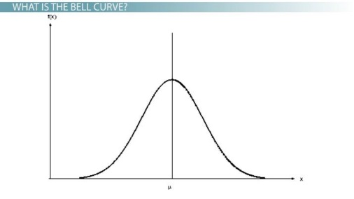

# Deliverables for Practical 2, Task 2:

## What are the p-values for the different tests?

|  |  |
| --- | --- |
| Comparison | P-Value |
| Asda vs Sainsbury | .126 |
| Asda vs Tesco | .166 |
| Sainsbury vs Tesco | 0.74 |

## Are there any significant differences between the search times for the websites? If so, between which sites?

Yes there is a large difference in the search times for Tesco as it is the most commonly underperforming compared to both Asda and Sainsburys. It has also got 2 cases of outliers compared to both other sites which had none.

## Provide an alternative and a null hypothesis for your experiment

Alterative hypothesis – All 3 sites will have distinct differences in time and will show a clear indication of the best from the worst.

Null hypothesis – All 3 sites will have the same or near enough the same time results and will be difficult to determine the best from the worst.

## When would you apply the Wilcoxon Signed Rank test?

A ‘Wilcoxon Signed Rank test’ would be applied when a dependent t-test is not suitable for the current situation. This is due to it not automatically assuming the data has got normality, it is used if the same participant has recorded two sets of times/ scores allowing for a fair comparison, this also suggests that it pairs up well with the within-subject design experiment.

## Do you think you should edit the raw data before you analyse them? If so, what would you do? If not, why not?

I believe that it would depend on what your intentions with the raw data are. If you are going to apply a Wilcoxon Signed Rank test then it will fine the way it is as it will not have an effect on the outcome.

However, if the raw data was going to be viewed and possibly plotted on a line graph then I would more than likely visually give them a rough order from lowest times to highest. For example, if there was clearly a faster time across all recorded levels then I would move this participants results higher up the table. Likewise, if there was a slower preforming participant I would move their results lower down the table. This will allow for an easier to read graph to be plotted where you are able to see clear differences. It also allows for the raw data to be easier to read if needed.

# Deliverables for Practical 3, Task 1:

## 5 initial survey items you created, with response categories:

1. Did the website allow for your own user needs (disabilities, languages, etc.)?
   1. The website provided assistance for all of my needs and was clear it provided assistance for others needs
   2. The website provided assistance for my needs but was not clear about providing assistance for others needs
   3. The website did not fully provide assistance for my needs however did show some attempts
   4. The website did not provide assistance for my needs however did provided assistance for others needs
   5. The website did not provide assistance for my needs or any other user needs
2. Did the simplicity of the website design speed up your search for what you wanted to find?
   1. The website design did have a positive effect on the speed of which it took me to find what I came to find.
   2. The website design sped up my search for what I came to find slightly
   3. The website design did not affect the speed of which it took me to find what I came to find
   4. The website design slowed down my search for what I wanted to find.
   5. The website design had a huge impact on my speed to find what I wanted which resulted in the item not being found due to the design.
3. How long would you say you spend on the website per each visit?
   1. > 1 minutes
   2. 1 => 2 minutes
   3. 2 => 5 minutes
   4. 5 => 10 minutes
   5. 10 => 30 minutes
   6. 30 => 60 minutes
   7. 1+ hour
4. Was the content on the website relevant to the pages that you were viewing?
   1. (open answered)
5. How did the layout and navigation of the website allow for easy learnability?
   1. (open answered)

## Changed survey items AFTER discussion with another student:

**Question 2** changed to:

Did the website design speed up your search for what you wanted to find?

**Question 5** changed to:

How did the layout and navigation of the website contribute towards learnability?

**Rest of questions were discussed and we agreed they should remain the same.**

## Briefly describe whether (and what) you changed in the items, what stayed the same and why?

The reason that the survey items where changed was due to each item being bias or suggesting something that the user might not think is true. For example, in the unchanged 2nd question it used the word ‘simplicity’ - this is suggesting that the website has got a simplistic design. This may result in changing the users thoughts or answer towards this question. The reason for this is because the user might not have thought the design was simplistic, however, with the question saying that it is, it can then give the user doubt consequently changing their opinion/answer.

The unchanged 5th question was also changed as it suggested that the website already had easy learnability. This might not have been true and the user might not have agreed with the question but the way that the question was worded would have resulted in the user talking about how easy the learnability is compared to how they truly think the learnability is.

# Deliverables for Practical 3, Task 2:

## 1.A table with the SUS survey statements and corresponding survey scores of your neighbour both raw and coded scores, with the OVERALL score based on your coding of the raw scores.

|  |  |  |  |  |  |  |  |  |  |  |
| --- | --- | --- | --- | --- | --- | --- | --- | --- | --- | --- |
| My survey scores (raw scores) | 4 | 2 | 4 | 1 | 3 | 4 | 4 | 2 | 4 | 2 |
| My coded scores | 2 | 4 | 2 | 5 | 1 | 2 | 2 | 4 | 2 | 4 |
| My coded scores total | 27 |  | | | | | | | | |
| My overall SUS score | 70 |  |  |  |  |  |  |  |  |  |
|  |  |  |  |  |  |  |  |  |  |  |
| My neighbour’s survey scores (raw scores) | 3 | 4 | 3 | 2 | 3 | 4 | 2 | 3 | 2 | 3 |
| My neighbour’s coded scores | 2 | 1 | 2 | 3 | 2 | 1 | 1 | 2 | 1 | 2 |
| My neighbour’s coded scores total | 17 |  |  |  |  |  |  |  |  |  |
| My neighbour’s overall SUS score | 42.5 |  |  |  |  |  |  |  |  |  |

## 2.Based on the statistical test you ran on the SUS scores for the Asda and Tesco websites (in file SUS_Data), what is the p-value?

0.028 p-value

## 2.Indicate whether there is a significant difference between the SUS overall scores for Asda and Tesco (or not), and why you conclude that?

It is clear that there is a highly significant difference between the sus overall score for ASDA and Tesco, one reason for this is that you can see when comparing the sus recorded scores that Tesco often had a higher score; sometimes by over 30 in a good amount of cases. However, the best evidence to support this would be the p-vale which is 0.028 which shows that there is a large difference as the p value is smaller than 0.05 suggesting that the null hypothesis was rejected.

## 2.List your assumptions for selecting the test(s) you have chosen?

The reason I selected the p-value test was to be able to see a clear indication of whether there is a significant difference or not. The reason I only carried out the p-value and no others was due to the clear indication of it being a significant difference by the number being so low. As the p-value was 0.028 this is a very clear indication and does not need any more tests to be conducted to back it up. For example however, if I returned with the p-value of 0.03 >= 0.05 then I would have done further tests.

## Copy in the SPSS output file that displays your output window for the statistical analysis.

|  |  |  |  |  |  |
| --- | --- | --- | --- | --- | --- |
| **Paired Samples Statistics** | | | | | |
|  | | Mean | N | Std. Deviation | Std. Error Mean |
| Pair 1 | Asda | 43.90 | 20 | 17.051 | 3.813 |
| Tesco | 56.10 | 20 | 16.108 | 3.602 |

|  |  |  |  |  |
| --- | --- | --- | --- | --- |
| **Paired Samples Correlations** | | | | |
|  | | N | Correlation | Sig. |
| Pair 1 | Asda & Tesco | 20 | .045 | .852 |

|  |  |  |  |  |  |  |  |  |  |
| --- | --- | --- | --- | --- | --- | --- | --- | --- | --- |
| **Paired Samples Test** | | | | | | | | | |
|  | | Paired Differences | | | | | t | df | Sig. (2-tailed) |
| Mean | Std. Deviation | Std. Error Mean | 95% Confidence Interval of the Difference | |
| Lower | Upper |
| Pair 1 | Asda - Tesco | -12.200 | 22.927 | 5.127 | -22.930 | -1.470 | -2.380 | 19 | .028 |

## 2.Provide an alternative and a null hypothesis for the test

Alterative hypothesis – Both sites will have significant differences in the time taken and this will be reflected in the SUS results therefore altering the overall value of the p-value and keeping it under 0.05.

Null hypothesis – Both sites will have very similar mean results meaning that there is little to no significant differences, therefore resulting in the SUS values being similar as well as the p-value being over 0.05.

## 3. What is the calculated Cronbach’s Alpha value (based on the CronbachsAlpha data file)?

.776

## Describe whether this is a sufficient measure of consistency for the test or not (around 80 words).

This is a sufficient measure of consistency as it is great for measuring internal consistency. It is a great way to figure out what you should change about your survey and what works well within it. A number higher than 0.6 but less than 0.7 is considered to be questionable and above 0.7 is considered acceptable or good, anything below 0.6 is when a survey should be reviewed. This is very beneficial as a user can simply look at a number to determine if their survey is giving out consistent results meaning it is sufficient and reliable enough. And if it is then this means that it is going to be more beneficial to the user using the information gained.

## 3. Indicate whether exclusion of questions (if so, which ones) may enhance the consistency of the survey.

The Cronbach alpha value suggests that the survey has got acceptable results which further suggests there is no questions that needs to be changed. However, if the survey aims to get a higher consistency score then it should possible review the 1st items question about ‘Frequency of use’.

# Deliverables for Practical 4, Task 1:

## Provide an explanation of one design application of a Gestalt principle in the HCI area and explain which Gestalt principle(s) is/are reflected in the design.

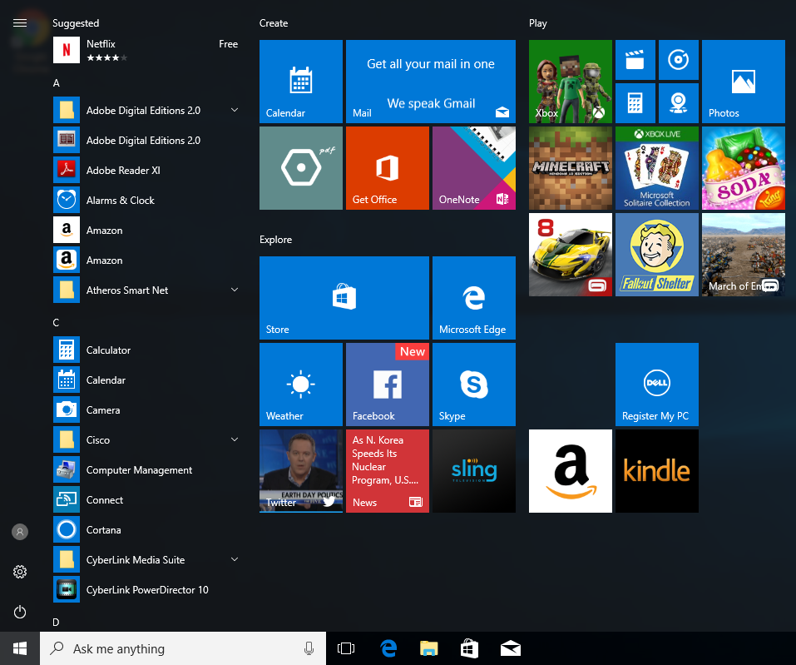

I chose the windows 10 start menu as my example as it uses 4 different Gestalt principles, which are ‘law of proximity’, ‘law of similarity’, ‘law of common region’ and ‘law of closure’. Here is my reasons to support why I believe these are all used within this HCI design:

#### Law of Proximity:

Law of proximity is used within this design as you can see that spacing has been used here to spread out and group up the icons. For example, groups of icons are split up by larger spaces between one and other, however the icons within the group are very close to each other therefore perceiving them to be in one group.

#### Law of Similarity:

Law of similarity can be seen within the different groups of icons. For example, if we start on the left of the menu, we can see a power icon, cog representing the settings and an account icon, all of which share a similar shape of a circle. If we then move onto the right, we find the list of ‘Suggested’, which we can then see that these are all in a group due to the similarity in design, they have all got the same sized icon with the same icon background colour and then have the name of the application in a clear same sized white font.

## Decide how you would expect the 5 different control actions to work and why you would expect them to work in the way you described.

#### 1. decrease volume

I would expect a decrease volume control to work in a way that the further left something is the lower the volume is and the further right the higher it is. One of the many reasons is that it should follow the same methodology that we have been born into using. For example, we read left to right, the clock’s hands go from left to right, screw drivers and screws work by also turning clock-wise (left to right) and a lot of other things follow the same pattern. The thought process behind it can be linked to time for example, if we were to look at a time line, we would have the lower number on the left and the higher number on the right.

I also talked to another student that thought the same as me but believed that it should be linked to other things such as when we drive. For example, we have our peddles in the order: “break”, “clutch” and “accelerate”, he believes that’s the reason it is left to right as the brake represents - “quieter”, the clutch represents - “middle” and the accelerate represents - “louder”. However, after talking to him I think his thoughts could have been related as the first car was developed in 1885 and the first radio volume control was created in 1901.

Another older student said that the would not initially do something however they would first test to see which way did which and then use that information to decrease the sound. This shows that different generations will have different approaches to things for example the younger generation would automatically know what to do because they are used to it and don’t need to think about it. However, an older generation might not automatically have this information to make an educated guess therefore will have to carry out a test to find out.

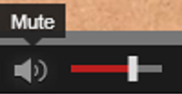

#### 2. ‘turn over’ page on tablet

If I was to ‘turn over’ a page on a tablet I would expect to swipe from right to left, the reason behind this is that we do the same when we are reading a normal paper paged book therefore, I would assume that this would work in the same way. The reason I think we swipe from the right-hand side of the screen over to the left is because we read from left to right (which means the next word is always on our right). This would then infer that we should follow the same pattern to get to the next word, which we know will be on the next page just like it is in a paper paged book. As we now know the next page is where we want to go and we need to go to the right of us to get to it, it only makes sense that we should swipe right to left due to this allowing for the page to fold over onto itself in a logical way.

I again talked to another group of students and all of which agreed that I was related to the way we get to the next page inside of a paper paged book. However one of the students also said that there has been times that their child has simply not known how to turn a paged book at they are use to pressing an arrow which showed that it has impacted a generation of children so much that they are learning different things first and in a different order.

#### 3. scrolling up a playlist

If I wanted to scroll up a playlist from the bottom, I would expect it to have me swipe down on the screen. I would also expect the control action to take into consideration how quickly/ harshly I swiped down and depending on that information it would take me up the playlist at different distances. The reason that I believe that they should act this way is because I would imagine it as pulling down the rest of the songs from the top of the screen and into our view. I would also think that the harshness of the swipe would affect the distance that is travelled in the playlist as this is a common way to travel through the list of songs at a faster speed.

After talking to the other students, they believed that the harshness of the swipe effecting the distance travelled through the songs is due to it being a lot more smoother giving a more pleasurable experience. They also said that they would initially look for a bar on the side to slide before trying to just swipe as they find it quicker, they then went on to say that before that they would look for a search bar to find the song the wanted. This demonstrated that the user will most of the time look for the quickest way to do something.

#### 4. accelerate car in game

If I was to play a car racing game, I would initially think that one of the back triggers of the console’s handset would be the accelerate button, the reason I think this is because I would link it to my car and how I drive that. In my car to accelerate I would press my foot down on the accelerate pedal which would allow me to pick up speed, this has now become more normal for me to do. As the trigger acts like a upside down accelerate pedal, I would feel more comfortable pressing that as it is most realistic thing to press.

I then talked to an older student that would have start by pressing the stick to the right (on the same console controller I talked about), they said the reason behind this was when they played a racing game when they were a child they would move the stick to the right to go forward and left to go back as it was a 3d game. This shows that controls have aged over the years and been developed.

#### 5. assign ring controls to cooker elements

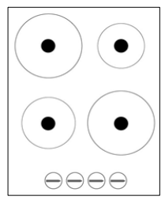

If I was to choose what ring control matches up with what cooker element it would look like what I displayed in the image above. The reason that I chose this was because I first looked at the big plate in the top left then the one in the top right then bottom left and then finally bottom right. As this could simply be my random choice, I did some research and found that users will often eye scan something in an ‘F’ shape starting at the top left then to the right, then move down and repeat. I also did some logical thinking and then related it back to the decrease volume scenario where a user would carry out a task from left to right and then move down. Now I knew what order the cooker elements would be looked at I then use the same information of looking left to right and thought about pairing the first seen cooker element with the first seen ring control, etc.

I then talked to other students from the class who all had the same approach to the assignment of the cooker elements and ring controls. However, some did not as they believed that the first cooker element that would have been seen would be the bottom right one. This is because this one is the biggest and closest to the centre of the rectangle making the user drawn to it more. This then allowed me to realise that it would depend on where the user first looks to which order would be best for them.

Sources:

Babich, N.B. (2017) *F-Shaped Pattern for Reading Content* [Online]. Available at: https://uxplanet.org/f-shaped-pattern-for-reading-content-80af79cd3394/ (Accessed: 15 February 2019)

# Deliverables for Practical 4, Task 2:

## A brief statement explaining which plate(s) would be more suitable for a blind user, and why.

I believe that the best plate would be plate B the reason for this is due to it having more surface space than C which will allow for better organisation of the food so it can be put into group of things such as rice, meat, veg and the blind user will have a better experience than if it was in C which will be more mixed and harder to tell what they are eating therefore not giving them much choice of order to eat it in and how to eat it. B is also better than A as the food on plate A will be a lot easier to fall off the plate. The side of the pate will allow the blind user to use the side of the plate to help get their food onto their fork.

## 2. A brief statement explaining which problems older users may have with ATMs and why.

Some older users may not have much experience with ATMs which can be a big security issue as well as making it hard for them to withdraw money. On of the problems with older people using ATMs is that they can not see the text on the screen and even when they do, they sometimes cannot understand some of the key words such as “PIN” they might simply not know what their “PIN” is. Security is also a large problem with older people and ATMs the reason being is that people can often forget their cards and when an older person is concentrating figuring out how to get money out, they simply forget about their card and walk away, however this problem has been solved with most ATMs not giving money out until the card is taken.

# Deliverables for Practical 5, Task 1:

## Notes from Steps

#### Step 1

###### **Make brief notes on the user, and 4 activities students need to perform in order to access the app.**

The typical user of this application will be a Discovery Dundee student that is looking for a support service from the university and is wanting to find out more information about it as well as the staff that are involved.

4 activities students need to perform in order to access the app:

1. Enter a university student email
2. Enter matching password to email in order to login
3. Answer a question for what they are looking for (so they can be directed to the correct page)
4. Click on the service that they want to use

###### **Make brief notes (one word or one sentence per bullet point) on the form of the device students may use:**

• the device type

* Student users are most likely to use mobile phones, laptops and computers to access application

• its size

* The size of the devices the students will use will range from mobile phones being around 5.6 inches, a laptop being 16.1 inches and computers around 22.1 inches

• when and where it is used

* A student is most likely to use it anywhere and everywhere however research has shown that students are most likely to book things when they are commuting from one place to another such as on a bus.

• constraints that may be present

* Some constraints to the devices the students may be using is if they are able to get internet access to access the application or not; if the screen size does not work with bootstrap page layout changer.

• anything else that might be important with respect to its form

* Users will possibly be using different types of software on the phone to access the web application such as a iPhone user will most likely use safari where as android users will most likely use google chrome.

###### **Make brief notes (one sentence per bullet point) on the posture required for of the device:**

• where is the user’s attention typically focused when using it (full attention, divided etc.)

* A users attention when using a device is situational based for example if the user was walking in the street they would be watching for cars therefor their attention would be divided, however if they were not moving then the device would have their full attention.

• how does the system respond to the user (immediately, delayed etc.)

* The system response to the user immediately however can have a slight delay if they have bad connection to the internet and are trying to access something that requires internet access.

###### **Make brief notes (one sentence per bullet point) on the inputs required for the device:**

• input devices used mainly: mouse, keypad, touchscreens, voice etc.

* The laptops and computers will most often only be mouse and keyboard however they might have a touch screen that can be used for input, the touchscreen for input will also be on the mobile phones for input and will display a virtual keyboard.

• other input devices you may envisage as a possibility: mouse, keypad, touchscreen, etc

* I will also have a look at microphones as a input device as this can be used for people with disabilities such as blind people.

#### Step 2

###### **Consider two data elements your app is meant to display, and describe/(note down) if/how they are linked (around 250 words in total)**

My app will display a calendar as this will be used for showing available appointments for certain services and this will then allow the user to book an appointment at an available time with their desired support service. The staff information will also be used as this will be able to show how many staff are available within each support service department, as well as showing who is available along with their specialties in certain areas.

Both two data elements are linked because if we did not display the staff information along with the calendar then the user will not know when they can book an appointment with a certain support service, as the availability would not be there. Without it then the user would be required to do trial and error, by trying to book an appointment on a date and see if the system accepts their booking date.

The staff information being displayed along with the calendar will also allow them to have a backup option for example if the “finance” support team was busy all week, then the user would be able see that. However, they can also see that the “advisory” support team is available for the week which might be another option for them to go to, depending on the issue they have.

###### **Note down the main ways of interacting with those elements, e.g. download, click etc. (one sentence)**

The main way to interact with both will be clicking as the staff info will have a drop down for each staff which will display details, and the calendar will be interactive.

###### **Note down 2 standards you must consider (e.g. web standards, accessibility, ISO etc.)**

Accessibility is a standard that I must consider as users are always using different devices to access the web and without my application making it accessible to the different types of devices then it will result in a bad user experience.

Strong security is a required standard for my application as without it the database that the user would be using could be easily targeted resulting in users details being stolen.

###### **Think about the overall design structure – are there any design principles you need to consider? Note down 1 design principle you find important and why (2 sentences).**

I will need to consider all design principles in my application as without considering them then I will more than likely no produce the best app for the users. One of the most important principles is visibility as the application must have a clear indication to what will happened and what to do next as without it the user may feel lost or unwelcome.

###### **Note down 1 design pattern you think is important for your app and describe why (around 100 words).**

One design pattern that I find the most important is a responsive design feature, this links back to the accessibility standard that I will be wanting to include. Without providing a responsive design certain device will not show the app in a helpful and understandable layout and will confuse the user into leaving the site. If the app does not provide a responsive layout then users may not only see the site and not feel comfortable using it as it feels like an effort to use but they mist also not find the information that they can onto the site to use.

#### Step 3

###### **Play devil’s advocate: Note down 1 what-if question, where you identify a problem a potential patient may encounter with your website. Describe in a few sentences why you think your problem is an issue and how you would address this issue.**

What if the user has bad eye site can not see the text on the app?

My problem is an issue as it is common that as people get older their eyesight will get worse even if they don’t go blind. This means that if a user was using a smaller device such as a phone or tablet the size of the text will go smaller to fit on the screen and if they already struggle to see it on a normal sized desktop screen then they will struggle more.

To address this issue then I would add a button in large text that has the words ‘Enlarge text’ – this button would then allow the user to click it and enlarge the text by a couple of pixels each click. I could also have a button that would read out each section on a site so if we had a section on “disability support service” there would be a volume icon in the corner of the section, so the user can click it and have the text read out to them. I could include both as this will address more than one disability issue as one requires hearing and one requires site however having them both allows for both issues to be addressed.

# Deliverables for Practical 5, Task 2:

## Notes from Steps

#### Step 1

###### **Note down 3 user experiences (1 sentence per experience) you want to achieve with your website and how you want to create this experience.**

#### Step 2

###### **Overall Colour for website:**

Light Blue - #88BDBC (Sample below)

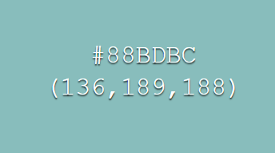

###### **Consider where the website is used (e.g. environment) and consider the characteristics of a user accessing this site.**

###### The website will most likely be accessed when at home or when the student is commuting to and from places, the characteristics of the user accessing the site will be busy as they are a student therefore wanting a quick and clean access through the app.

###### **Create a colour scheme for your site that is appropriate for a University context**

Dominant/ primary colour:

* Very dark blue - #112D32 (Sample below)

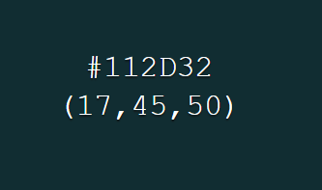

Accent/ secondary colours:

* Darker brown - #4F4A41 (Sample below)

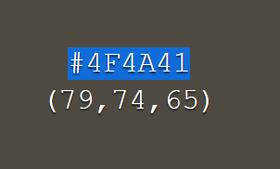

* Light brown - #6E5558 (Sample below)

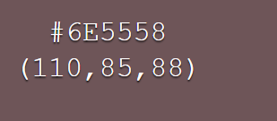

Background colour:

* Light Blue - #88BDBC (Sample below)



###### **Note down a justification for your colour selection and provide a colour patch so we can get an idea of the general appearance of your pages (around 100 word).**

The reason that I chose my colour theme was due to light blue being a calming colour which might be needed as the user is on the site to look for a SUPPORT service, which suggests that something is wrong and can sometimes lead to people being stressed. The calming blue colour will therefor assist the user with feeling calmer. I also chose different shades of brown to help make the site have a sleeker and more professional look with it. I also conducted some pallet tests that showed that the different shades of brown match well with the blue.

Colour patch:

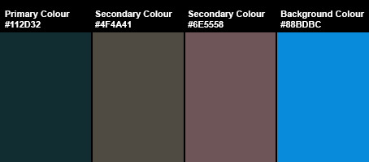

Website Pages Samples:

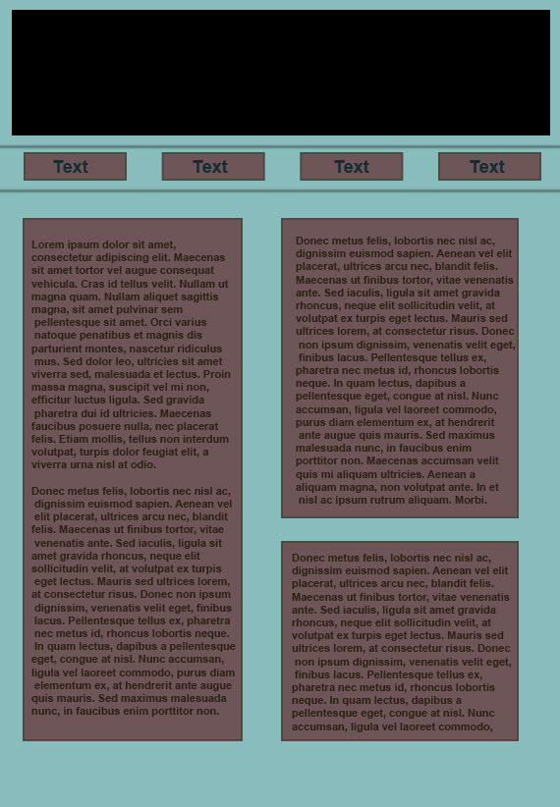

###### **Select a visual style.**

The visual style that I like is this one:

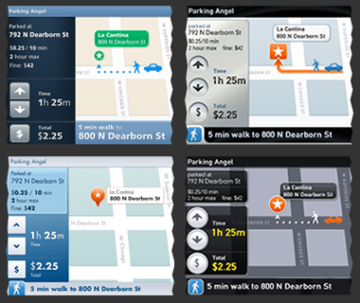

As it gives a clear indication of what things are, the colours work very well and are laid out in a good manner which allows you to see the information. The style shows the separate areas clearly allowing for a quick glance to give all the information you need without distracting you from the road ahead.